**Step 1.1:**

I think it could be useful for users to search by the following search terms:

* Recipe Name
* Cooking Time
* Ingredients List
* Difficulty
* Date Created

**Step 3.1:**

Data Analysis

* Bar Chart
  + Cooking time (x) vs. date created (y)
* Pie Chart
  + Name (x) vs. cooking time (y)
* Line Chart
  + Date (x) created vs. name (y)

Charts will be displayed only based on user input

**Step 5.1:**

Execution Flow

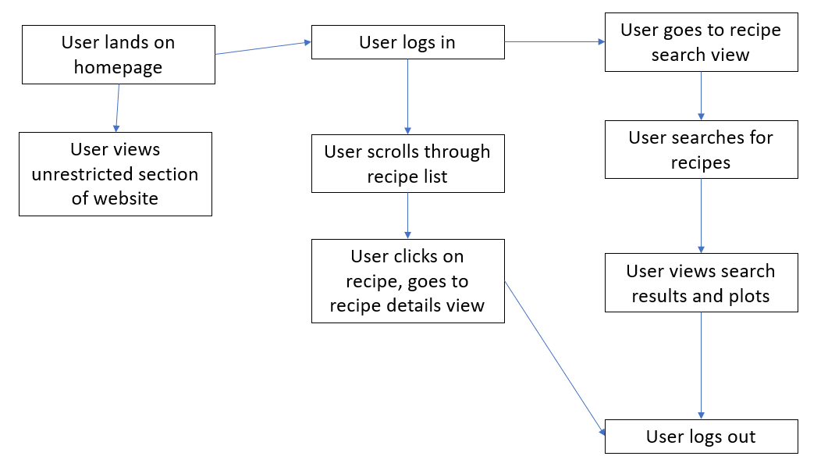

**Step 5.4:**

* User lands on homepage:
  + 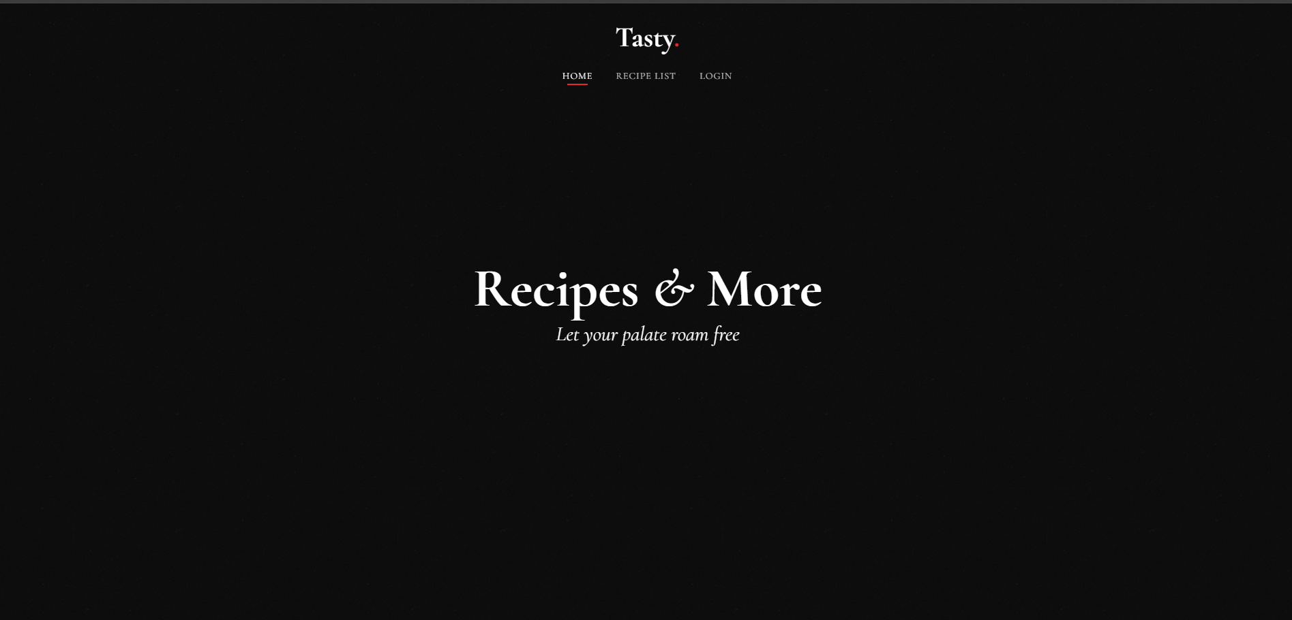
* User views unrestricted section of website
  + 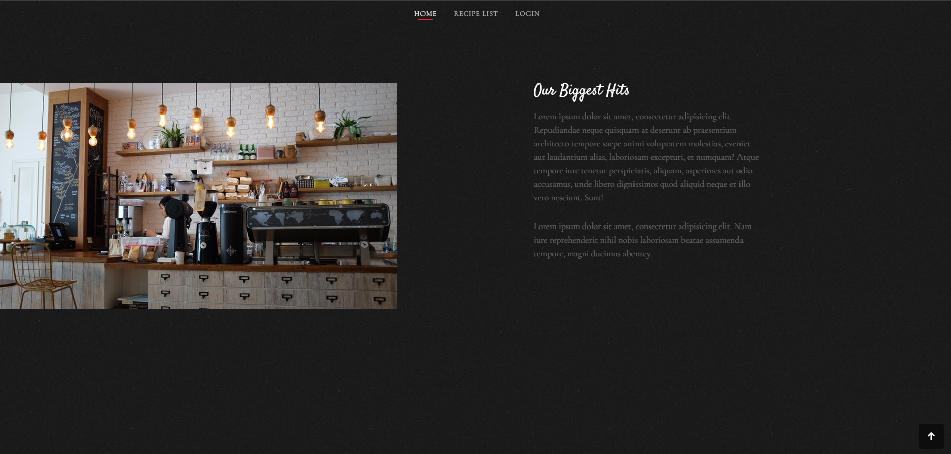
* User logs in
  + 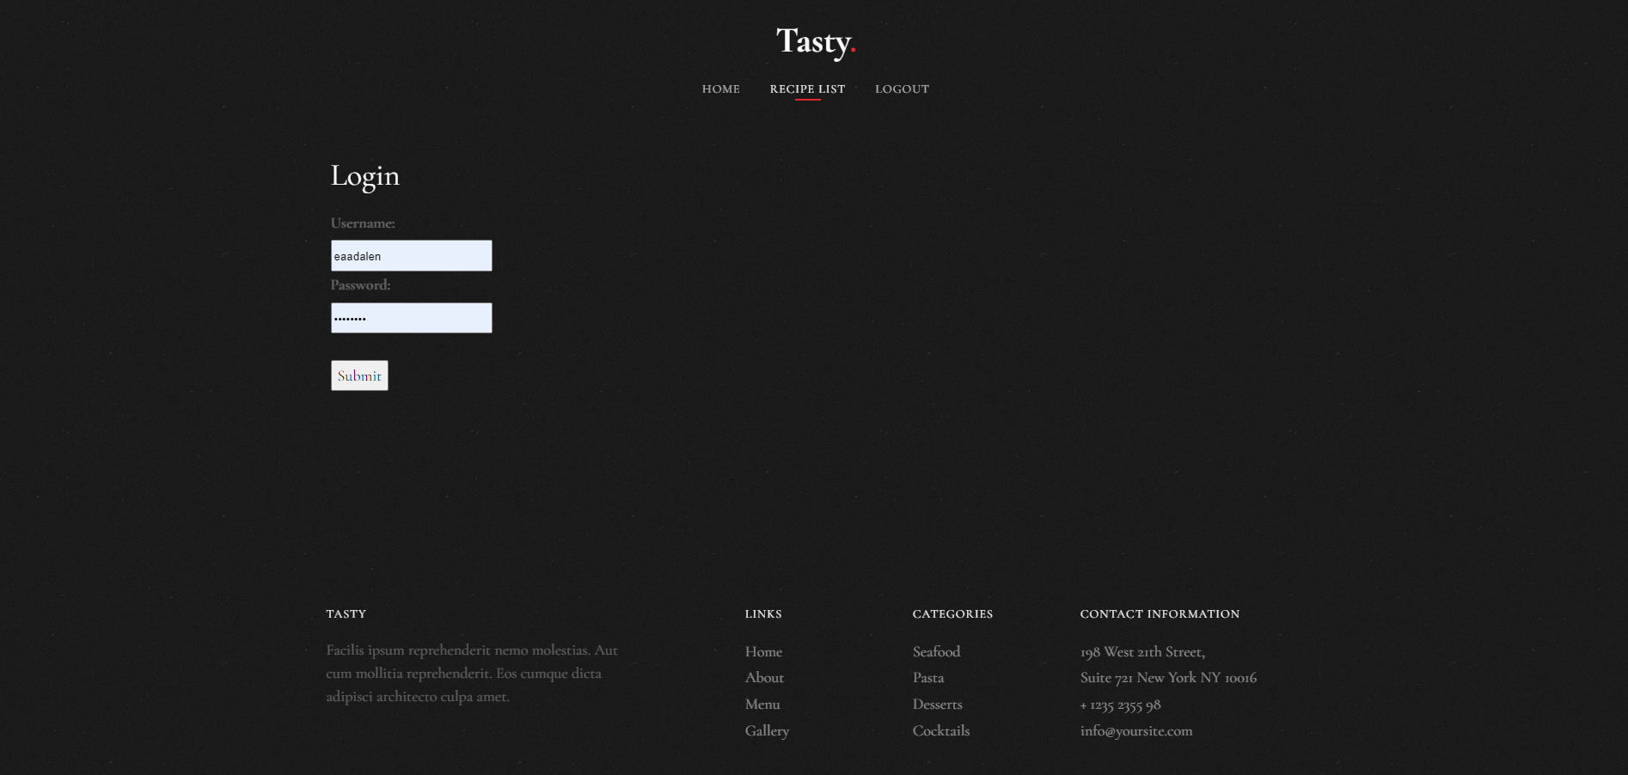
* User scrolls through recipe list
  + 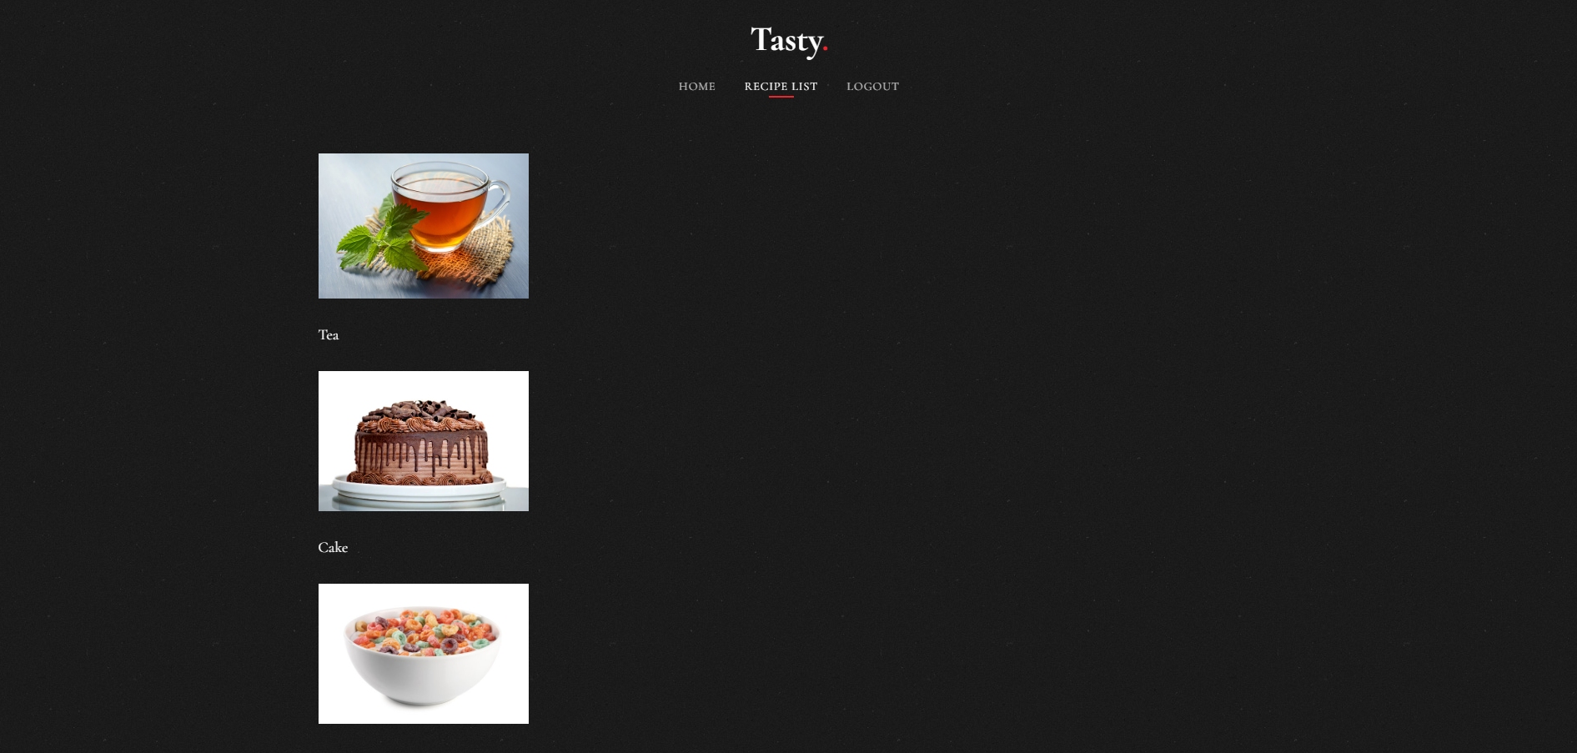
* User clicks on recipe, goes to recipe details view
  + 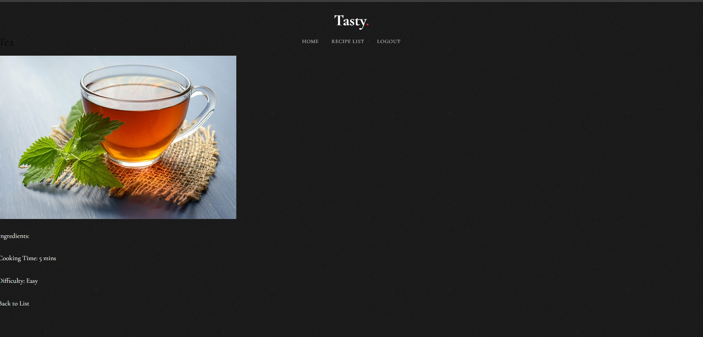
* User goes to recipe search view
  + 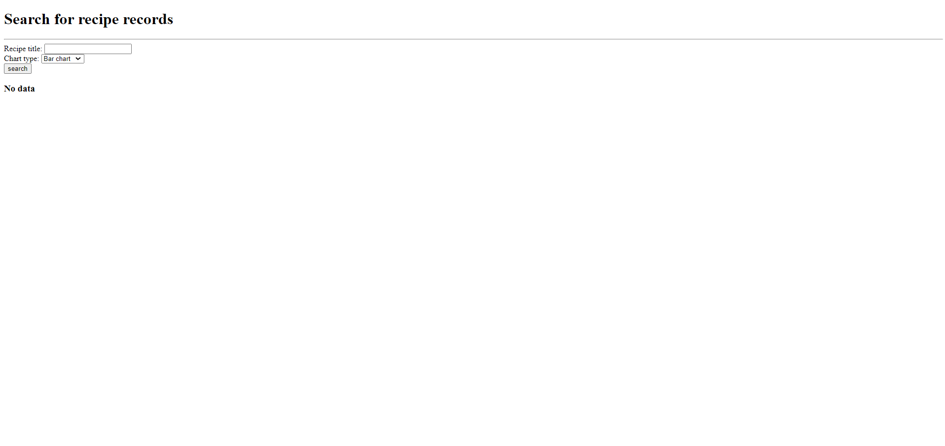
* User searches for recipes
  + 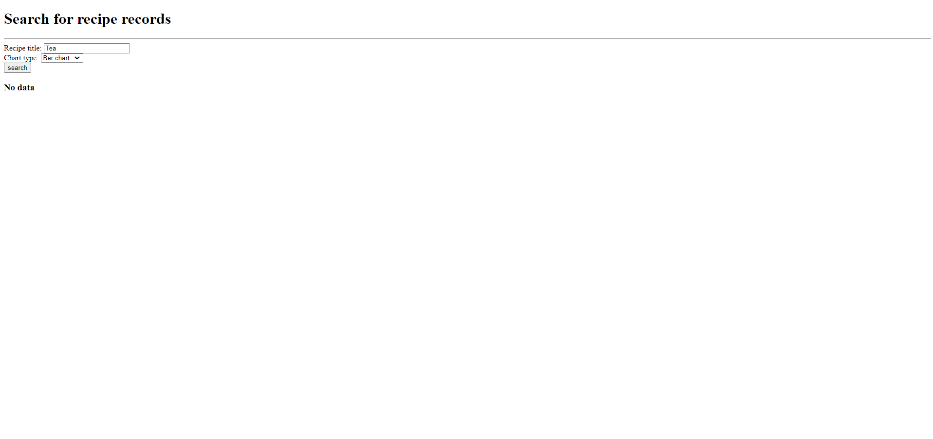
* User views search results and plots
  + 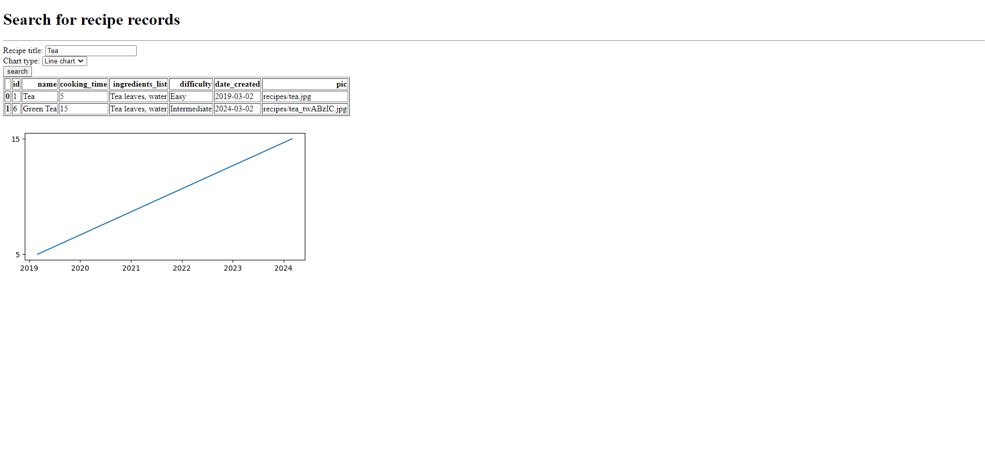
* User logs out
  + 